DATE: 04.01.2019
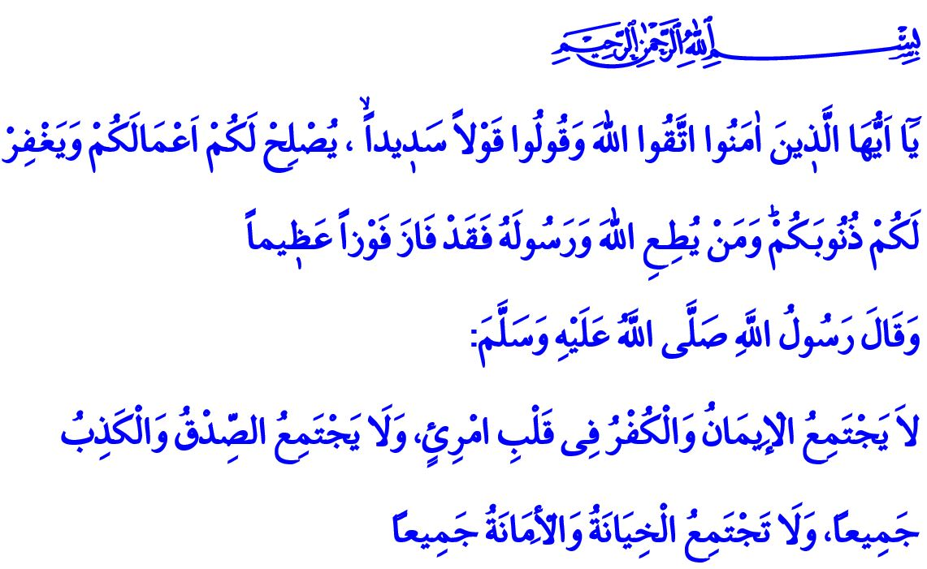
BEING TRUE IN ESSENCE AND WORDS
Honorable Muslims!
Allah the Almighty (swt) states in the verses I have recited: “O you who have believed, fear Allah and speak words of appropriate justice. He will [then] amend for you your deeds and forgive you your sins. And whoever obeys Allah and His Messenger has certainly attained the highest achievement.”
Our Beloved Prophet (saw) declares in the hadith I have read: “A combination of blasphemy and faith, lying and righteousness, treason and trustworthiness cannot coexist in a person’s heart together.”
Esteemed Believers!
Islam attaches great importance to the truth, verity, and to always telling what is right. It could be seen by the fact that al-Sidq, which means truthfulness and honesty, is the first attribute of the prophets. The first moral virtue that comes to mind when we think of Muslims is, again, truthfulness. Because truthfulness is the light of salvation, the essence of hidayah (guidance), and a requirement of high morality. True word is the voice of faith; and telling what is right is the principle of the believer. In this context, our Beloved Prophet (saw) said: “He who believes in Allah and in the last day should either speak good or keep silent.”
Dear Muslims!
Truthfulness is goodness while lying is evil. Truthfulness is mercy while lying is a disaster. The right finds its place with truthfulness; and loses its place with lies. The property acquired by truthfulness becomes fruitful and blessed. There is no goodness in anything acquired by lies. Honor and dignity become permanent with truthfulness. One attains the countenance of Allah (swt) with truthfulness. The punishment of Hell is the only destination to be reached by lies. In the sight of Allah (swt), the value of the word is measured by the degree to which it reflects the right and the truth. Because word is the interpreter of the heart, and the mirror of our essence and soul. Our Prophet (saw) warned the Ummah in this regard with the following words: “It is obligatory for you to tell the truth, for truth leads to virtue and virtue leads to Paradise. The person who continues to speak the truth and endeavors to tell the truth is eventually recorded as ‘truthful’ with Allah. And beware of telling a lie for telling a lie leads to obscenity and obscenity leads to Hell-Fire. The person who keeps telling lies and endeavors to tell a lie is recorded as ‘liar’ with Allah.”
Esteemed Believers!
Most of the time, a lie burns the fire of discord in the society, disseminates corruption, ends friendships, causes harm to the innocent and the loss of rights. The underlying reason for the damage of trust in the family, decrease of love and respect, and eventually the destruction of the families is again, to lie. Confidence in business and trade is gained only by truthfulness. A righteous institution ultimately earns benefit for both this life and for the Hereafter. Those who deceive the society, try to cover their tricks by fancy words, and do not refrain from even giving false oath for this cause are doomed to go bankrupt in both worlds. The Messenger of Allah (saw), who is the best example for the Ummah with his words and behaviors, was so sensitive about lying that, he forbade even lying to children or joking by lying. When he saw a woman calling her child by saying, “Come here and I shall give you something.”, he asked, “What did you intend to give him?”, and as she answered, “I intended to give him some dates.”, he (saw) said, “Beware! If you were not to give him anything, a lie would be recorded against you.”
Honorable Believers!
As lying is a sinful behavior, accepting any heard news to be true without searching, and causing the spread of a lie deliberately or not are the behaviors that require the same degree of responsibility in terms of religion and morality. In this regard, Allah the Exalted (swt) warns us in the Holy Qur’an as: “And do not pursue that of which you have no knowledge. Indeed, the hearing, the sight and the heart - about all those [one] will be questioned.”
Valued Believers!
Let us never talk against anyone’s dignity and honor no matter what their religion, race, denomination, and lifestyle are. Let us pursue the truth and the verity. Let us adopt truthfulness, respect and kindness as our principles. Let us not forget that we will give account for each word on the Day of Judgment. Let us avoid from lie, which darkens and pollutes our hearts, and most of the time turns our lives upside down. Let us be true in our essence and our words.

Ahzab, 33/70, 71.
Ibn Hanbal, II, 349.
Abu Dawud, Adab, 122, 123.
Muslim, Birr, 105.
Abu Dawud, Adab, 80.
Isra, 17/36. General Directorate of Religious Services

